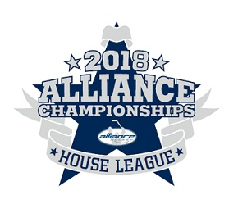
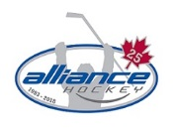

2018 ALLIANCE Hockey House League Championships – Rules
Hosted by: Woodstock Minor Hockey Association
- Hockey Canada rules will apply. The Tournament Chair has final say on all tournament rules, regulations and protests.

- The OHF suspension list will be used to assess all major, Misconduct and Match Penalties. The Tournament Chair may add to the suspension, if appropriate. If a player or coach receives a suspension during the tournament, the team must check with the Tournament to confirm the number of games to be served. Any player receiving a fighting major will be suspended for the duration of the Championships.

- The Tournament Committee reserves the right to make any or all decisions.

- Teams are required to provide the Tournament Office with their roster and travel permit prior to their first game. All teams will be limited to a maximum of 19 players. Teams are allowed a maximum of 5 Team Officials on the bench. The home team is designated by the tournament schedule. The home team wears dark jerseys. In the case of conflicting sweaters, the home team will change.

- Affiliated players (AP’s) are not permitted with the exception of Goaltenders.

- Teams shall be prepared to play 15 minutes ahead of scheduled start times.

- No one is allowed on the ice until the ice surfacing machine has left the ice and the doors are closed. Upon conclusion of each game, players will meet at center ice and shake hands, unless the referee(s) determines it is inadvisable to do so for reasons of players safety, etc.

- Dressing rooms are to be vacated promptly after the game has been completed. Arena staff will inspect the room prior to the next team entering. Keys for the dressing rooms are available in the Tournament Office located in the Red rink.

- There will be a 3 minute warm up prior to the start of each game.

- Games at Novice, Atom and Peewee will be 10-10-F-15 and games at Bantam and Midget will be 10- 15-F-15. No time outs are allowed in preliminary round. One(1) time out per team is allowed in Semi-Final and Final games. Floods will occur between the 2nd and 3rd periods, not at the end of the game.

- Points will be awarded as follows: Two(2) points for a win, one(1) point for a tie and zero(0) points for a loss. In case of a tie, except in the Semi-Finals and Finals, a sudden-victory OT period of five (5) minutes stop-time will be played, with each team reduced to four skaters plus a goalie. First goal scored shall determine the winner. If the score remains tied at the end of the five (5) minute Overtime period, each team will be awarded one(1) point.

- If teams are tied at end of round robin play, the final standings will be determined using the ALLIANCE Hockey tie breaking rule found in the Manual of Operations:
https://alliancehockey.com/Manuals/2430/Sections/2590/7_0_Tie-Breakers/
- In the case of a tie in Semi-Final and Final games, sudden-victory Overtime periods of ten (10) minutes stop-time will be played at regular strength. The first goal scored shall determine the winner.

- The Tournament Committee will not be responsible for any injuries incurred during the Tournament. All precautions will be taken to protect participants.

- There are no appeals. All decisions of the Tournament Committee and referee(s) are final.

